

**Project report**

Java Project

Table of Contents

Introduction 3

Project presentation 3

Project actors 4

Study of the need 5

Used software 6

Provisional schedule 7

Pert diagram 7

Production 8

JProject log 9

Conclusion 12

Effective schedule 12

Differences analysis 12

Encountered problems 12

Possible upgrades 12

Personal review 12

Group review 13

# Introduction

## Project presentation

For this object-oriented programing project, our client asks us to rewrite a famous game from 1984, “Boulder Dash”, a game where you must collect diamonds to move forward through the game while avoiding enemies and boulders.

we have to code it in JAVA and use Maven, which is a build automation tool used primarily for Java projects and a database to stock our different levels. In order to facilitate teamwork, we also need to use Git Hub which is an online versioning system. Finally, before we start coding, we need to model your program using diagrams such as class diagrams, components ...



## Project actors

Gautier VUILLAUME

Hugo ROUTY



Julien HENROTIN

Emmanuel BOUSSER



The project manager (Gautier) must ensure that the schedules are set up and maintained. It also manages the division of tasks and decision-making.

## Study of the need

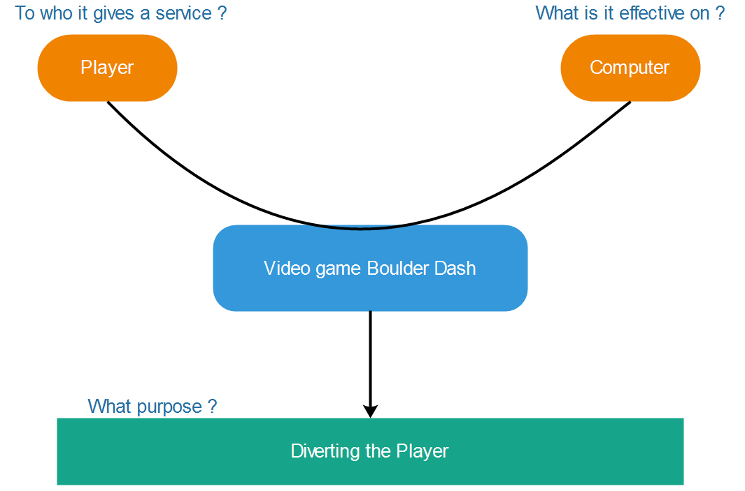Services diagram

Interactions diagram

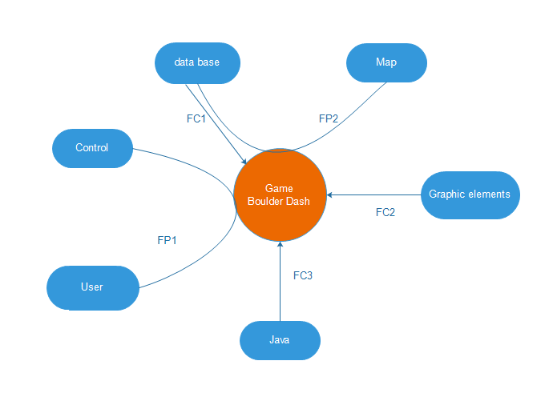

FP1: user can play to game with control on his keyboard

FP2: the map is stocked in database

FC1: The game uses the maps who is stocked in data base

FC2: The graphic elements are on an external file

FC3: The program runs under a Java environment

# Used software

|  |  |
| --- | --- |
|  | Java is a general-purpose computer programming language that is concurrent, class-based, object-oriented. |
| Afficher l'image d'origine | Office suite for the realization of deliverables and PPT. |
| Résultat de recherche d'images pour "discord" | Software to communicate easily. |
| Résultat de recherche d'images pour "gantt project logo" | Using Gantt Project to organize schedules. |
| Résultat de recherche d'images pour "wamp" Résultat de recherche d'images pour "mysql" | Using Wamp Server and the MySQL DBMS to build the database. |
| C:\Users\julie\AppData\Local\Microsoft\Windows\INetCache\Content.Word\eclipse.png | IDE use for developing our project. |
| Résultat de recherche d'images pour "jmerise logo" | Software for modeling Merise diagram (CMD…) |
| Résultat de recherche d'images pour "edraw logo" | Software for modeling class and package diagrams. |
| C:\Users\julie\Desktop\visual-paradigm.png | Software for modeling class and package diagrams. |
| C:\Users\julie\Desktop\git hub.png | GitHub is a web-based Git or version control repository and Internet hosting service. |

## Provisional schedule

We have made a Gantt diagram for represent our provisional schedule.

It is linked here:



## Pert diagram

To symbolize the tasks to be done to complete this project, we realized a pert diagram. It is linker here:



# Java modelling

## Class diagrams

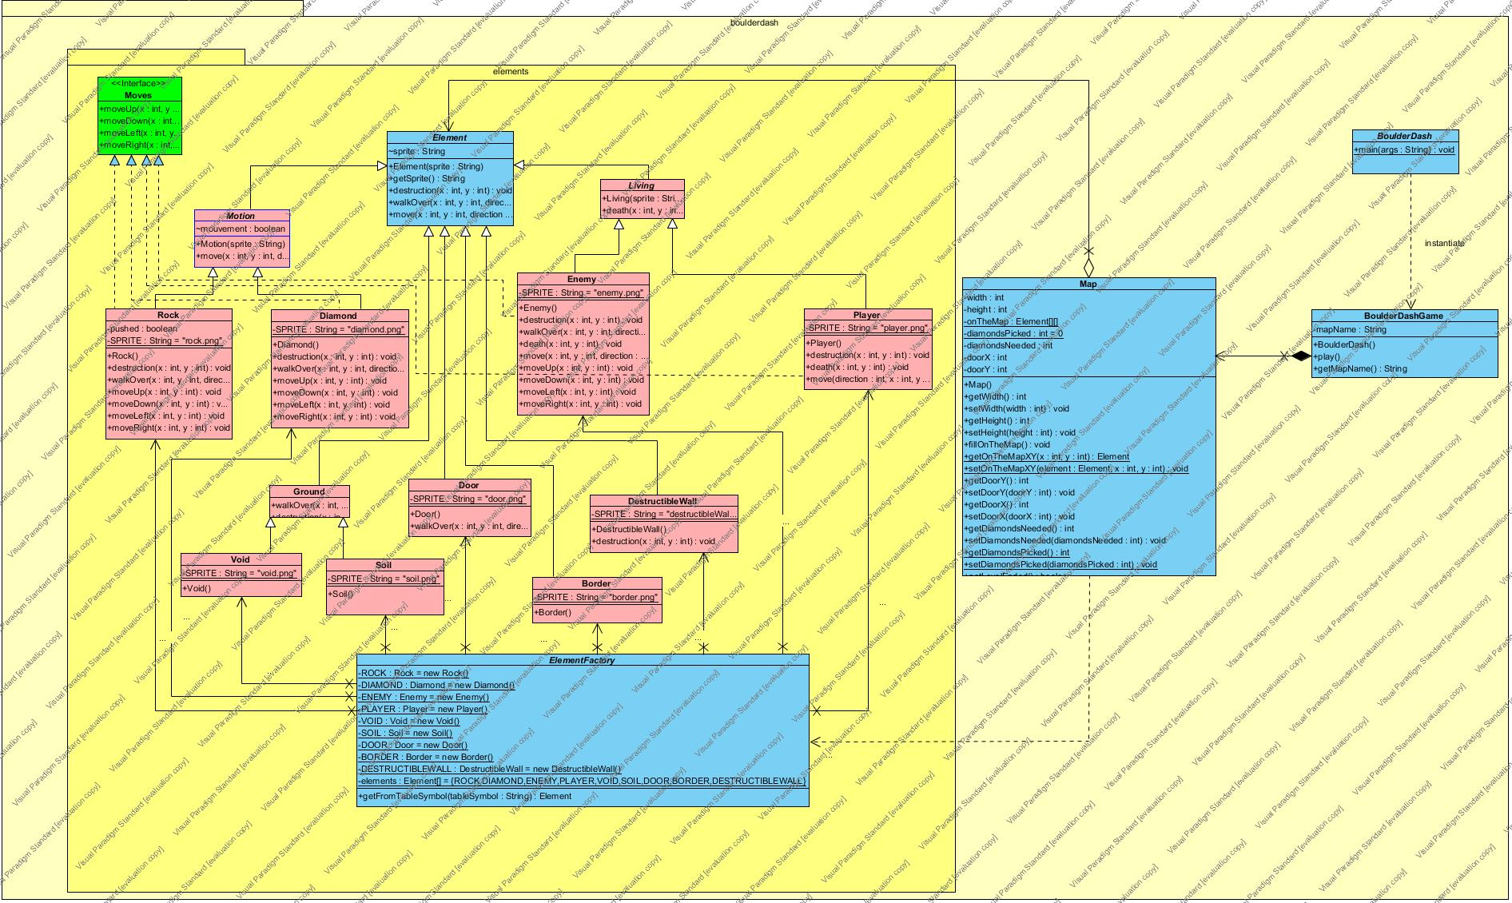

Global class Diagram without MVC

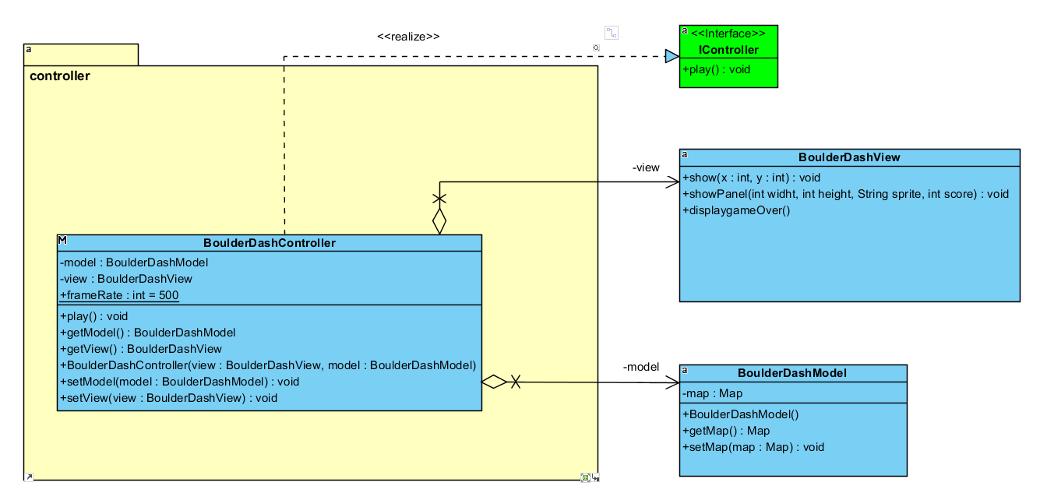

Controller class Diagram

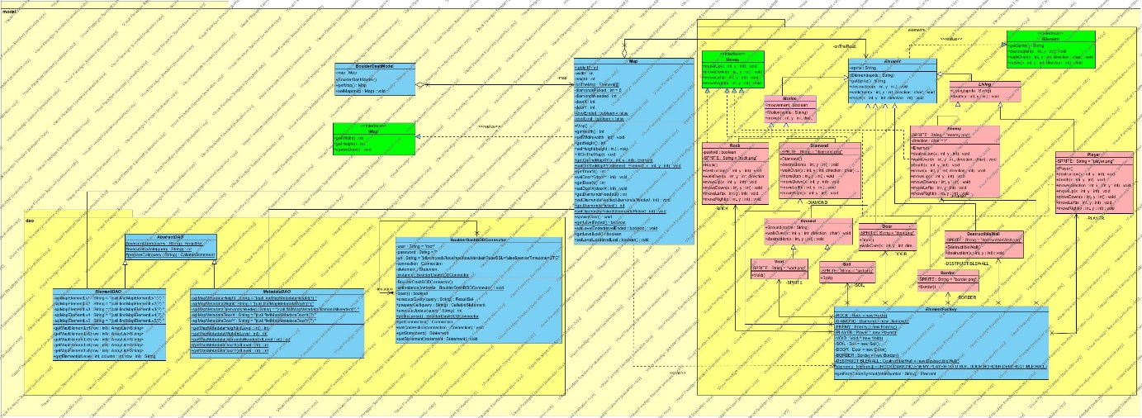

Model class Diagram

## Component diagram

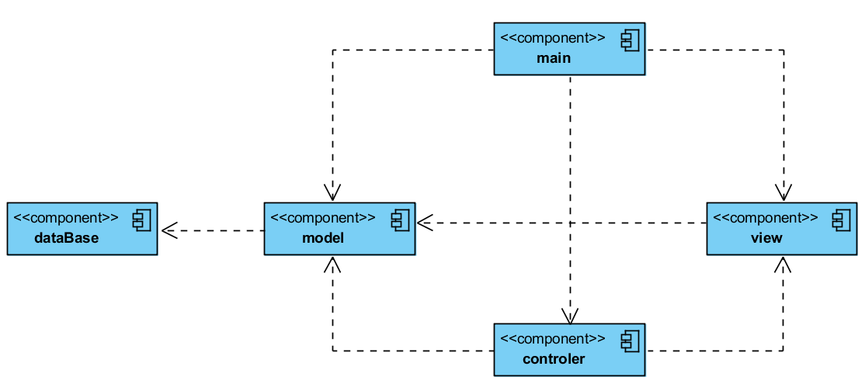

## Package diagram

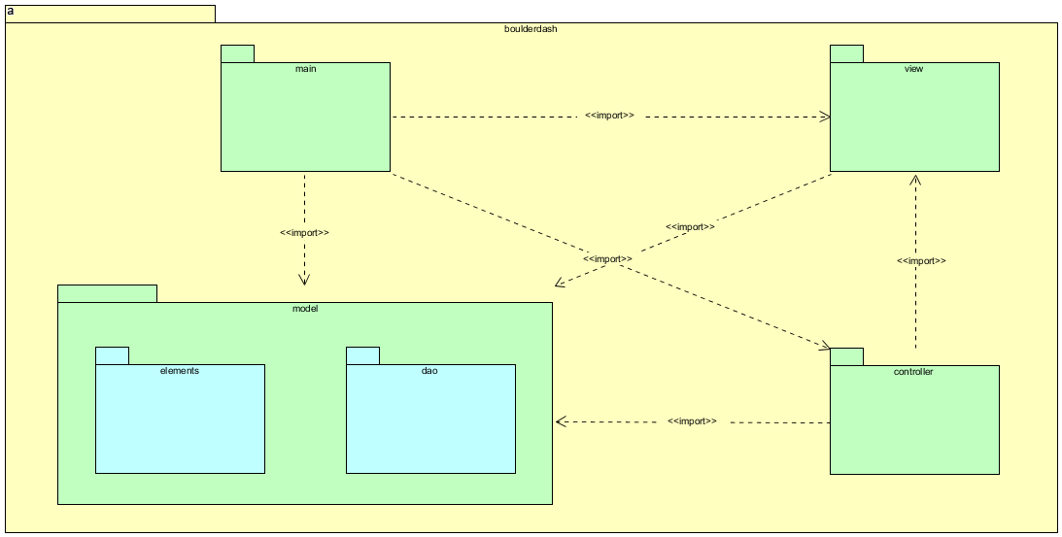

## 

## Sequence diagram

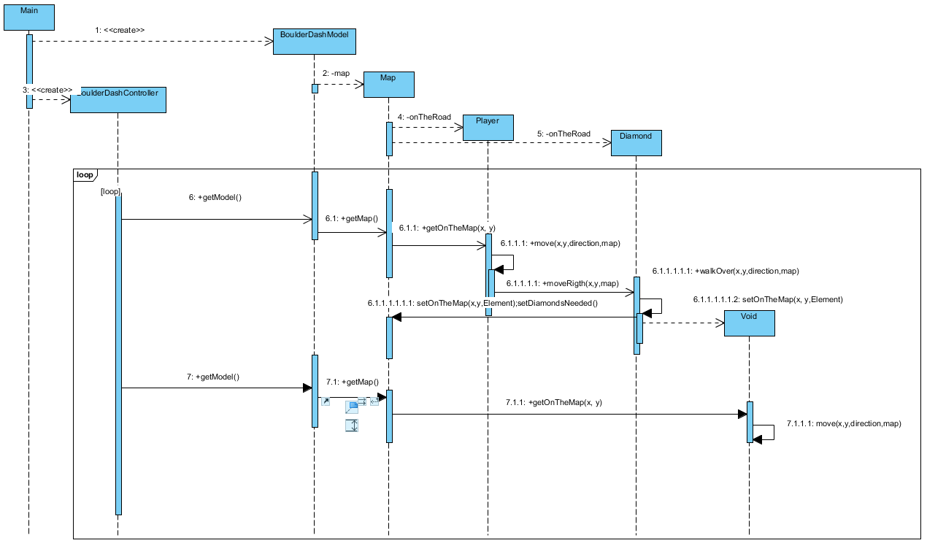

# Database modeling

## Data dictionary

Due to its large size, the data dictionary is available below:



## CDM

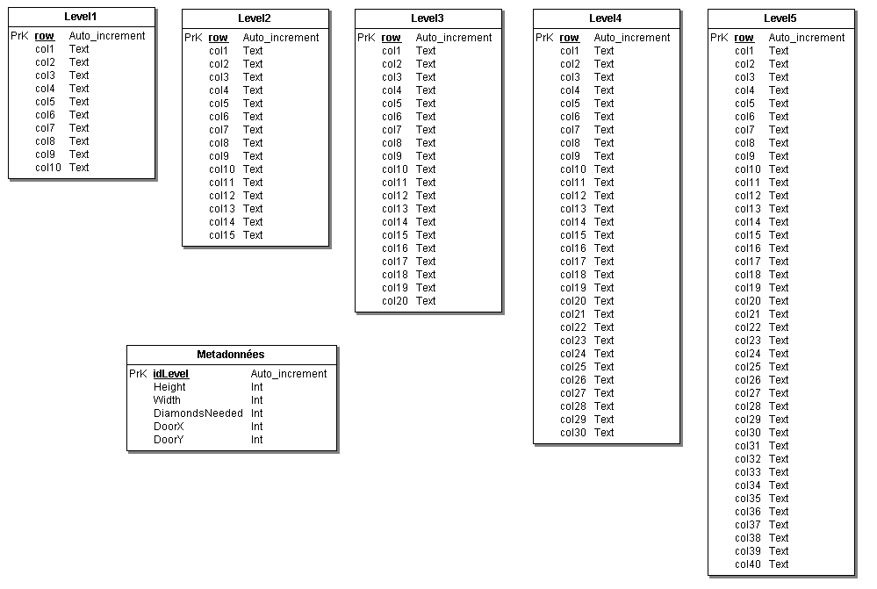

## 

## LDM

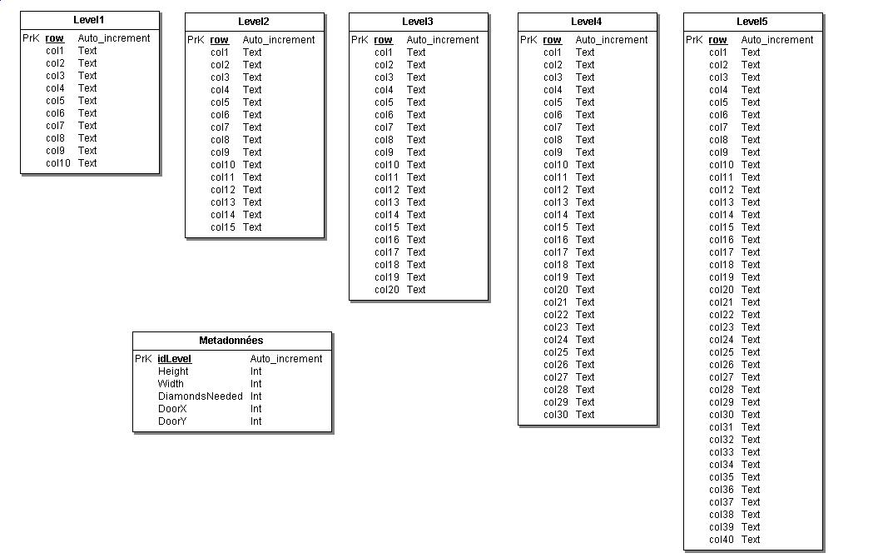

# Production

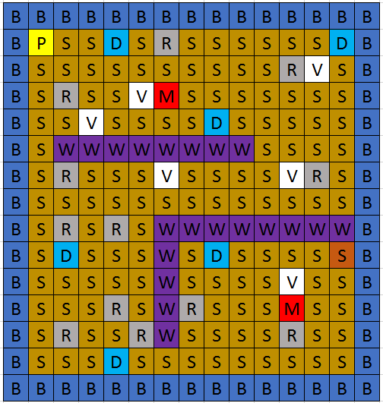 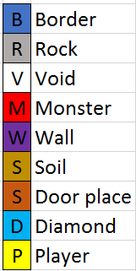

Map design on Microsoft Excel

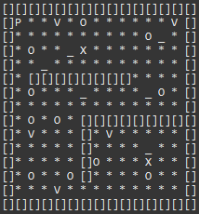 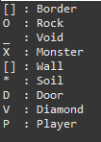

Map display on Eclipse console

# Project log

|  |  |  |
| --- | --- | --- |
| **Date** | **Team members** | **Tasks realized** |
| 13/06/17 | BOUSSER Emmanuel | * Subject study * Global class diagram * Git creation * Installation of the environment |
| HENROTIN Julien |
| ROUTY Hugo |
| VUILLAUME Gautier |
| 14/06/17 | **Team briefing –** *Forecast of day's work* | |
| BOUSSER Emmanuel | * Distribution of tasks * Provisional schedule * Global class diagram * MVC class diagrams |
| HENROTIN Julien |
| ROUTY Hugo |
| VUILLAUME Gautier |
| 15/06/17 | **Team briefing –** *Forecast of day work* | |
| BOUSSER Emmanuel | * Controller class diagram |
| HENROTIN Julien | * View class diagram * Functional analysis |
| ROUTY Hugo | * Data access object class diagram * CMD |
| VUILLAUME Gautier | * Model class diagram |
| 16/06/17 | **Team briefing –** *Forecast of day and week-end work* | |
| BOUSSER Emmanuel | * Controller class diagram |
| HENROTIN Julien | * View class diagram |
| ROUTY Hugo | * PERT Diagram * Cutting sprites * LMD * Data dictionary |
| VUILLAUME Gautier | * Model class diagram * Sequence diagram |
| 17/06/17 | BOUSSER Emmanuel | * Start of Junit tests |
| HENROTIN Julien | * Start of Junit tests |
| ROUTY Hugo | * Data base creation * Map creation |
| VUILLAUME Gautier | * Class diagram java export |

|  |  |  |
| --- | --- | --- |
| 18/06/17 | BOUSSER Emmanuel | * Junit test |
| HENROTIN Julien | * Junit test |
| ROUTY Hugo | * Data base filling * Stored procedures |
| VUILLAUME Gautier | * Starting coding Elements |
| 19/06/17 | **Team briefing –** *Forecast of day's work* | |
| BOUSSER Emmanuel | * Junit test and start controller code |
| HENROTIN Julien | * View code |
| ROUTY Hugo | * JUnit tests * Stored procedures |
| VUILLAUME Gautier | * Elements coding * Component diagram |
| 20/06/17 | **Team briefing –** *Forecast of day's work* | |
| BOUSSER Emmanuel | * Controller code |
| HENROTIN Julien | * View code |
| ROUTY Hugo | * Implementation of the java methods that will execute the stored procedures * Class diagram update * Component diagram update * Project Report |
| VUILLAUME Gautier | * Map code |
| 21/06/17 | **Team briefing –** *Forecast of day's work* | |
| BOUSSER Emmanuel | * Debug of controller and factory |
| HENROTIN Julien | * Debug of the view * Add Javadoc on the view code |
| ROUTY Hugo | * Debug the DAO code * Project report * Add Javadoc on the DAO code |
| VUILLAUME Gautier | * Debug of Map and elements * Element and Map Javadoc |

|  |  |  |
| --- | --- | --- |
| 22/06/17 | **Team briefing –** *Forecast of day's work* | |
| BOUSSER Emmanuel | * Controller Javadoc |
| HENROTIN Julien | * Debug of the view |
| ROUTY Hugo | * Effective schedule * Creation of map/data base test * Project report |
| VUILLAUME Gautier | * Implementation of a console view * Debug of elements |
| 23/06/17 | **Team briefing –** *Forecast of day and week-end work* | |
| BOUSSER Emmanuel | * Debug of some elements * Debug of a part of the view |
| HENROTIN Julien | * Debug of a part of the view |
| ROUTY Hugo | * Package diagram * Project report |
| VUILLAUME Gautier | * Debug of some elements |
| 24/06/17 | BOUSSER Emmanuel | * *Production of the slideshow* * *Oral preparation* |
| HENROTIN Julien |
| ROUTY Hugo |
| VUILLAUME Gautier |
| 25/06/17 | BOUSSER Emmanuel | * *Production of the slideshow* * *Oral preparation* |
| HENROTIN Julien |
| ROUTY Hugo |
| VUILLAUME Gautier |
| 26/06/17 | BOUSSER Emmanuel | * *Last update on the presentation* * **PRESENTATION** |
| HENROTIN Julien |
| ROUTY Hugo |
| VUILLAUME Gautier |

# Conclusion

## Effective schedule

We have made a Gantt diagram for represent our effective schedule.

It is linked here:

## Gap analysis

## Encountered problems

* Problem with Maven compilation, which was solved with a pom file modification.

## Possible upgrades

* Add a map to select the level like in the original game.
* Add a dual players mode.

## Personal review

* Emmanuel BOUSSER:
* Julien HENROTIN:

Thanks to this project I should participate to design of the complete to the design of an entire program.

Despite my difficulties in modelling I think I have made progress and have a group with I had a good agreement help me for work atmosphere.

* Hugo ROUTY:

I found this project very interesting because it allows us to implement everything we had seen during the various prosits. It also allows us to realize a software starting from the thinking and going up to the realization in passing by the modeling.

Our group was very pleasant and hardworking, which allowed us to respect our deadlines and to succeed in making something functional while maintaining a good atmosphere in the group throughout the project.

* Gautier VUILLAUME:

## Group review